Left

Background: top

Milestones: bottom

Middle

Materials: top

Diagram: middle/bottom

Right

Approach:

Challenges:

**Background/Project Goal**: Drones have a wide variety of uses such as film, journalism, surveillance, air strikes, and even bomb detection. In our project, we focus on having an autonomous follower drone to follow a primary leader drone. The project would help improve military technology by exploring ways to allow a single drone to communicate or control multiple autonomous drones.

Project Goal: Have follower drone follow the leader drone within (x distance)? <Expand on this>

**Milestones :** Breakdown and schedule of mini-goals to achieve your final goal for this quarter

* Hack drone API library
* Control leader via computer
* Leader drone sends GPS commands to follower drone

**Materials Needed:**

* Drones
* Raspberry Pi
* GPS Tracker
* **Four new laptops for communication**

**Diagrams**:

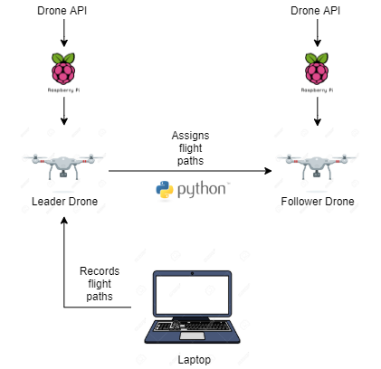

Diagram Explanation:

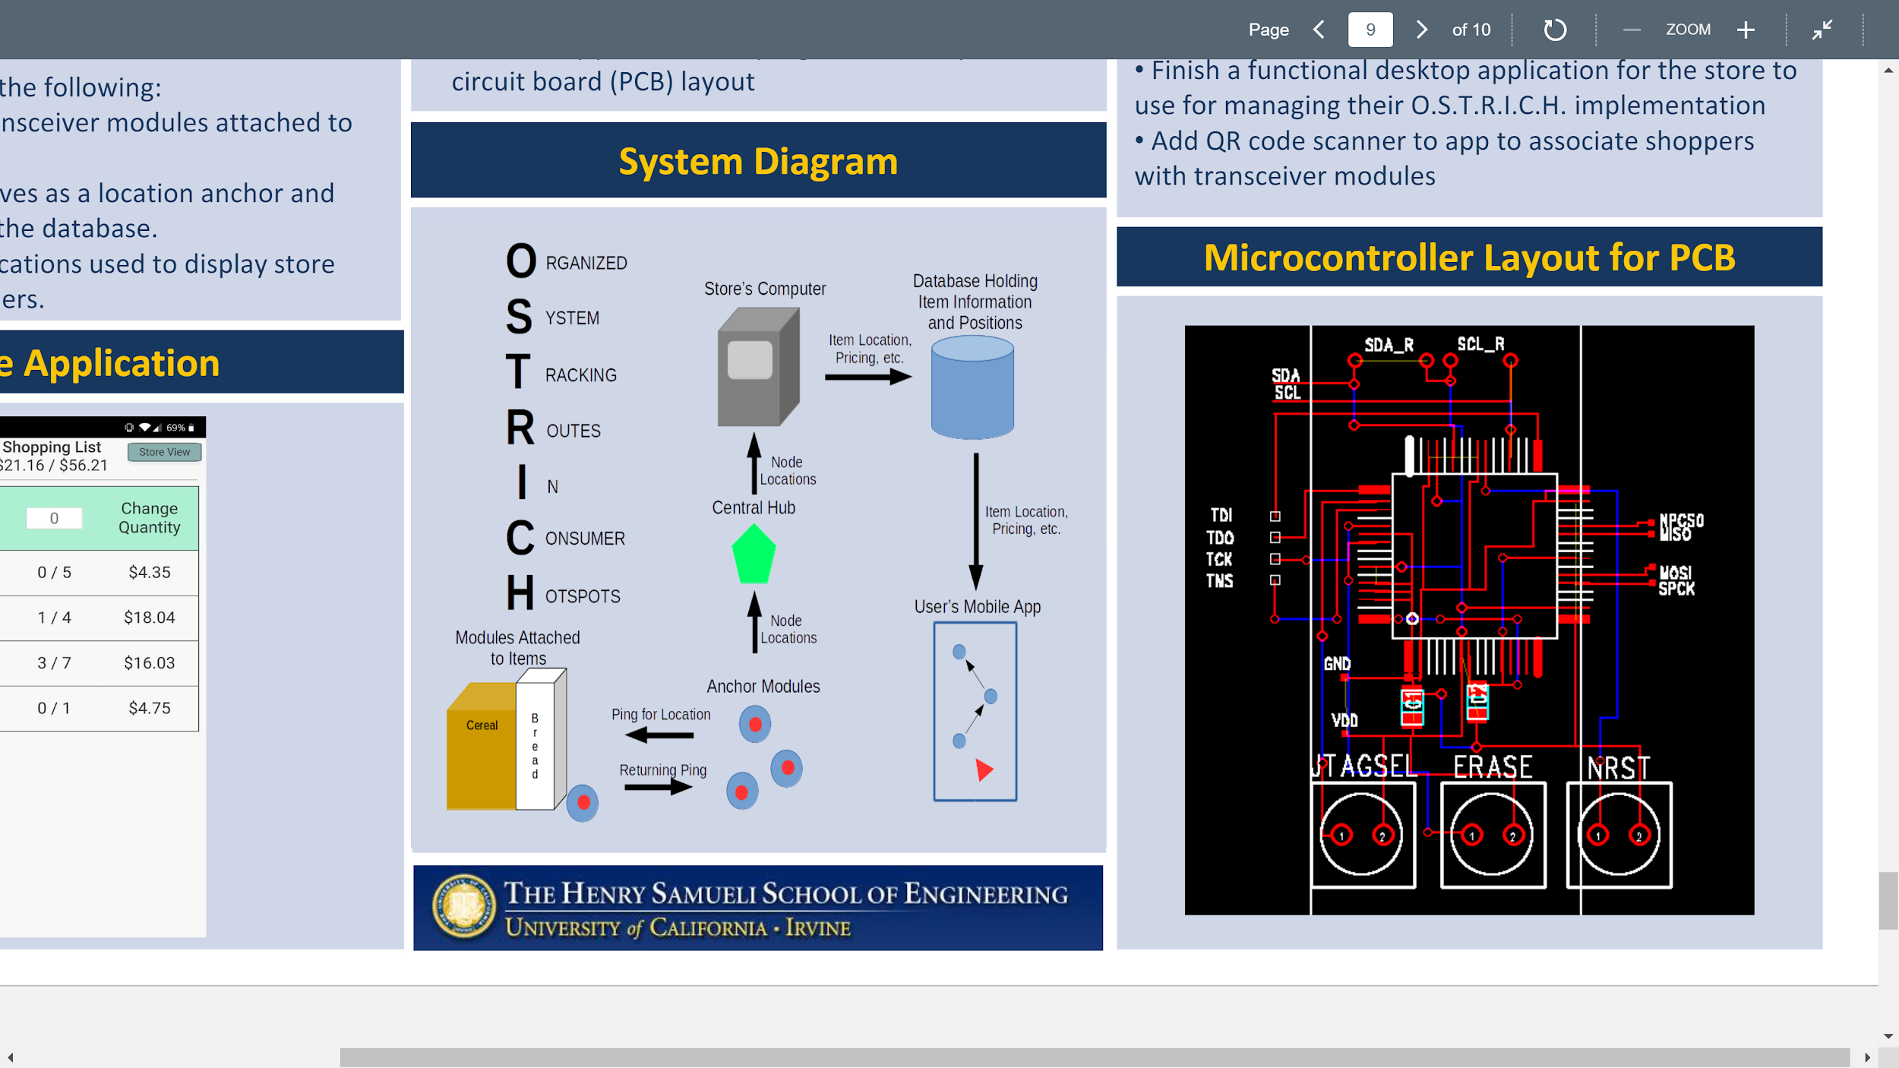

**References**:

<https://re.public.polimi.it/retrieve/handle/11311/983158/105936/mottola14team.pdf>

<https://onlinelibrary.wiley.com/doi/pdf/10.1002/net.21864>

<https://www.dronetrest.com/t/beginners-guide-to-drone-autopilots-flight-controllers-and-how-they-work/138>

<https://www.deviantart.com/davidhansson/art/Raspberry-Pi-3d-Logo-584059133>

<https://re.public.polimi.it/retrieve/handle/11311/983158/105936/mottola14team.pdf>